Lissajous Aiming In-depth

* Lissajous patterns are created when two perpendicular harmonic motions interact, creating a variety of different shapes depending on three factors
  + amplitude: peak/trough size
  + frequency: how fast the harmonic squiggles
  + phase change: one harmonic has a head start

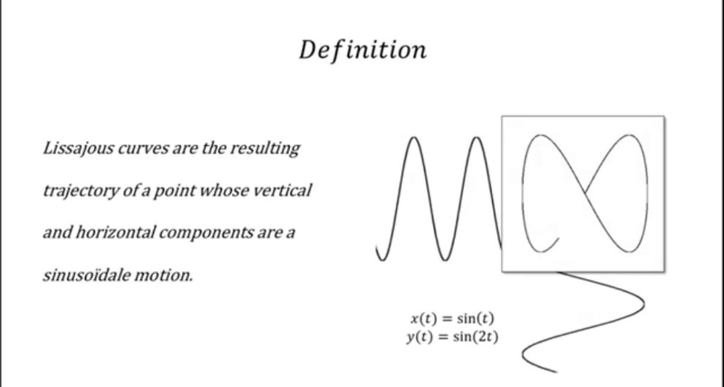

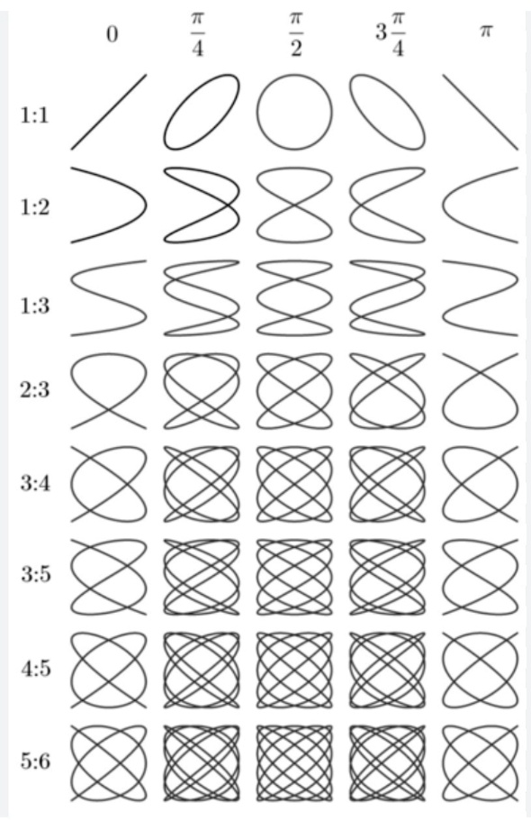

**What does any of this have to do with my thumb?**

* Lissajous patterns are seen in human movement
* Lissajous overview pictures (LOP) are often used in gait analysis
  + links to the articles are at the end of the document
* I am extrapolating this idea to thumb movement
* The right thumb stick requires the player to use conical motion of the carpometacarpal joint (CMC) along with flexion and extension of the metacarpophalangeal joint (MCP) and the interphalangeal joint (IP)
* 1) MCP/IP joint flexion + extension

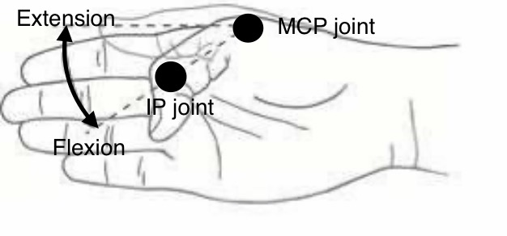

* 2) CMC joint flexion/extension + abduction/adduction

-when you do conical motion of just the CMC joint with the hand oriented as shown below, the circular cone base is tilted, so you perceive a 2d projection of a diagonal ellipse

* This is different from the diagonal ellipses seen in the chart below.

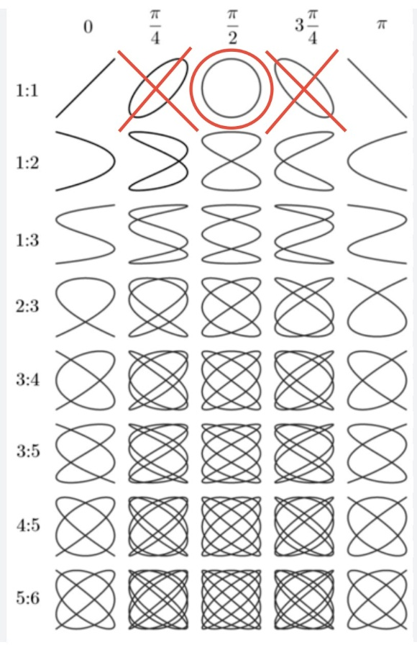

* When the cmc joint circumducts (conically twirls), it traces a circle, which has a phase change of π/2, but your perspective tilts the circle to appear like a diagonal ellipse
* However, the diagonal ellipses on the chart have phase changes of π/4 and 3π/4
* Things get a little more complicated when you add MCP/IP flexion into the mix
* The cone will tilt more, and the cone base will appear paper-thin, producing a squashed and bent figure 8, or what I like to call “Batman goggles”

* This is different from the butterfly figure 8s seen in the chart below. Those have phase changes of π/4 and 3π/4

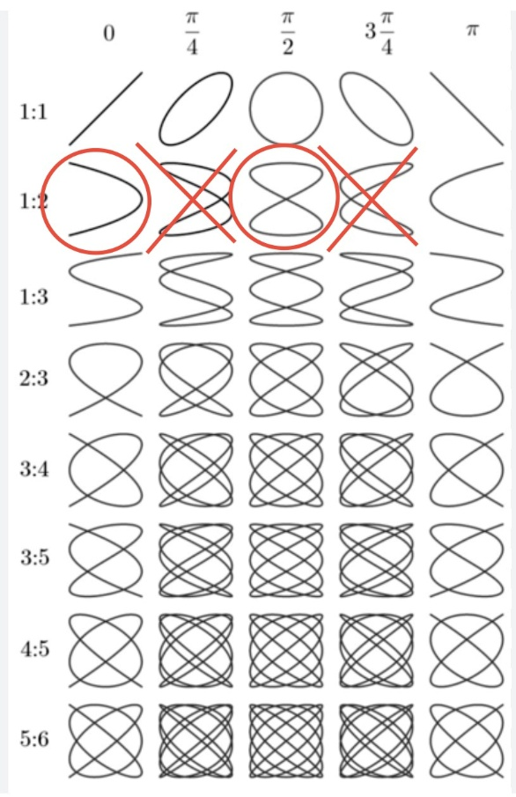

* The Batman goggles are formed by two Lissajous patterns being superimposed over each other
* One is a squashed figure 8
  + Squashed because the amplitudes differ between joint rotations
* The other is a U shape
  + This is the shape of a pendulum swing

**Conclusion**

I want to be very clear that I do not have a background in coding, but I do have a medical background as a family medicine physician. I worked with AI to generate an aim code that uses these Lissajous patterns as a guide for behavior mapping for right thumb stick aim. It is displacement based, not velocity based. If this code is implemented properly, it could add the missing yaw and pitch orbits to gyro ratcheting, thus creating true two-pivot aiming which I talk about more in my document “Lissajous Aiming: General Overview”

* If you have a controller with a right thumbstick, you can click the html links to test out the Lissajous aim code compared to other aim codes
* My recommendation would be to try and trace a small circle or ellipse that is 1 inch in diameter, and take as much time as you can to articulate the shape (the code is modified for DS5 controllers, just so you’re aware)
* Anecdotally, I can trace a small circle or ellipse accurately with the Lissajous aim code, but the other aim codes are jagged, almost like you’re tracing an onomatopoeia burst you would see in comic books



* I also have different size variations for the Lissajous shapes you can try out too. You can think of adjusting the size like adjusting mouse sensitivity
* If you’re interested in my idea, please shoot me an email so we can collaborate. Thank you.

Eric Wong

15wonge@gmail.com

Gait research links

<https://www.researchgate.net/profile/Masahiko-Mukaino/publication/305340291_Feasibility_of_a_Simplified_Clinically_Oriented_Three-dimensional_Gait_Analysis_System_for_the_Gait_Evaluation_of_Stroke_Patients/links/578a8fea08ae59aa66793d8d/Feasibility-of-a-Simplified-Clinically-Oriented-Three-dimensional-Gait-Analysis-System-for-the-Gait-Evaluation-of-Stroke-Patients.pdf?origin=publication_detail&_tp=eyJjb250ZXh0Ijp7ImZpcnN0UGFnZSI6InB1YmxpY2F0aW9uIiwicGFnZSI6InB1YmxpY2F0aW9uRG93bmxvYWQiLCJwcmV2aW91c1BhZ2UiOiJwdWJsaWNhdGlvbiJ9fQ>

<https://www.researchgate.net/profile/Eiichi-Saitoh-2/publication/291311206_Application_of_Lissajous_overview_picture_in_treadmill_gait_analysis/links/595c28d7458515117741c89b/Application-of-Lissajous-overview-picture-in-treadmill-gait-analysis.pdf?origin=publication_detail&_tp=eyJjb250ZXh0Ijp7ImZpcnN0UGFnZSI6InB1YmxpY2F0aW9uIiwicGFnZSI6InB1YmxpY2F0aW9uRG93bmxvYWQiLCJwcmV2aW91c1BhZ2UiOiJwdWJsaWNhdGlvbiJ9fQ>